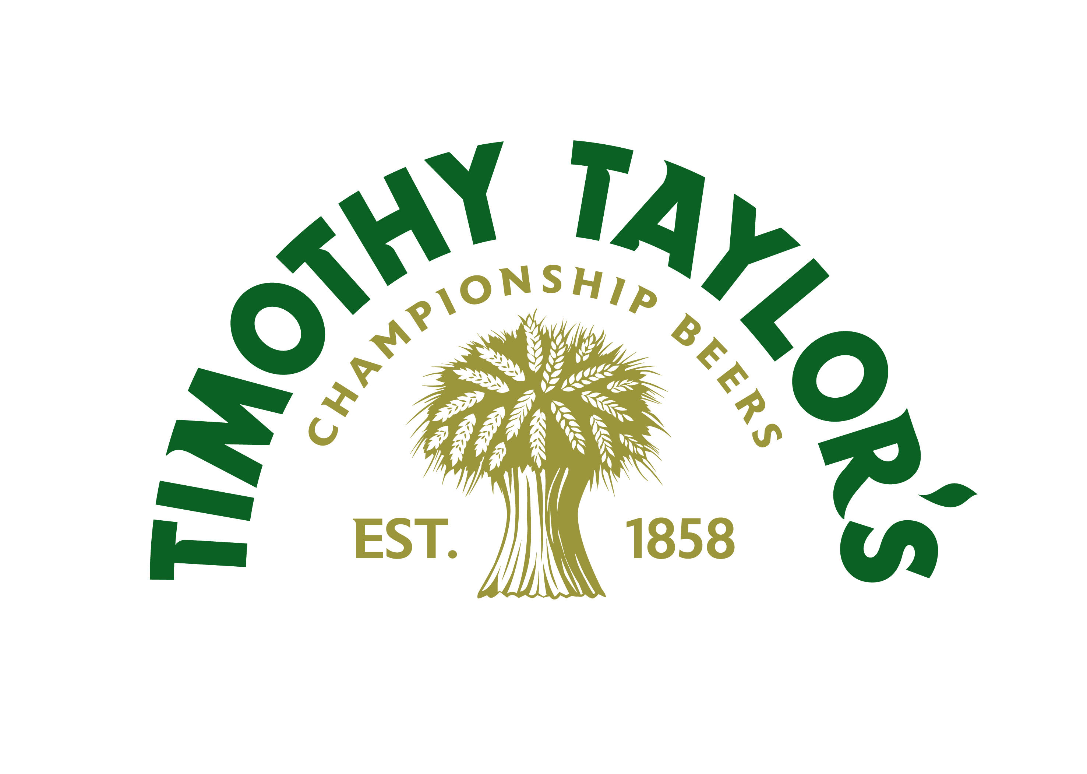
External Job Advert

Business Development Manager

Location: Ipswich, Norwich and Peterborough

An exciting opportunity to join one of Britain’s most respected and award-winning, independent breweries, where tradition, integrity and quality still lead the way.

Why join Timothy Taylor’s?
At Timothy Taylor’s, we don’t just brew beer - we brew legacy. Family-owned and proudly independent since 1858, we’ve built a reputation for doing things the right way, not the easy way. That commitment extends to our people too.

We’re now looking for a Business Development Manager to cover Ipswich, Norwich and Peterborough, and help us strengthen and grow our presence across this key region. You’ll be the face of Timothy Taylor’s, building trusted relationships with publicans, wholesalers and pub groups, uncovering new opportunities and ensuring every pint of Taylor’s is served at its best.

Key Responsibilities
- Manage a defined territory with a number of key permanent and guesting accounts, driving sales across on-trade RTM channels (free trade, wholesale, leased and tenanted, managed).
- Act as a key contact for RTM partners including wholesalers, brewers, and pub company managers.
- Identify and win new business while supporting existing customers to grow sales.
- Deliver added-value support: cask and cellar training, quality control, and resolving dispense issues.
- Organise and host engaging ‘Taste of Taylor’s’ events and represent the brand at trade shows and industry gatherings.
- Seek to take full responsibility for agreed regional wholesalers and key multiple customers.

What makes this role rewarding:
This is a hands-on, people-focused role with real variety. You’ll have the freedom to shape your territory, build lasting partnerships and see the direct impact of your work, from hosting events to helping pubs serve the perfect pint.

Who we are looking for:
We want a self-starter who thrives on building relationships and delivering results. You’ll bring:

- A proven track record in field sales (drinks industry desirable) or senior on-trade management.
- The confidence to manage your own territory and develop new business.
- Strong communication, influencing and presentation skills.

- Good IT skills, numeracy and a full, clean UK driving licence.
- A hands-on approach and passion for great beer and the Timothy Taylor’s brand

Our culture
At Timothy Taylor’s, quality is everything - in our beers, our people and the way we work. We are professional but down-to-earth, structured but friendly. We avoid unnecessary bureaucracy and focus on doing things properly - with integrity, precision and pride.

What we offer
We believe great work deserves great rewards. As part of the Timothy Taylor’s team, you’ll enjoy a comprehensive benefits package designed to support your wellbeing, work-life balance and long-term development, including:

- 25 days’ holiday, plus bank holidays
- Company car
- Workplace pension
- Profit share bonus scheme
- Private healthcare (family option) and life cover
- Company sick pay and family-friendly policies
- WeCare: 24/7 GP, mental health support, fitness programmes and nutrition guidance
- ToothFairy: dental app, offering instant access to real UK dentists
- Professional development support

Interested?
If you’re passionate about great beer and building strong relationships, we’d love to hear from you. For further details and to apply, please contact our recruitment partner: JS Search & Selection – jack@jssearch.co.uk

