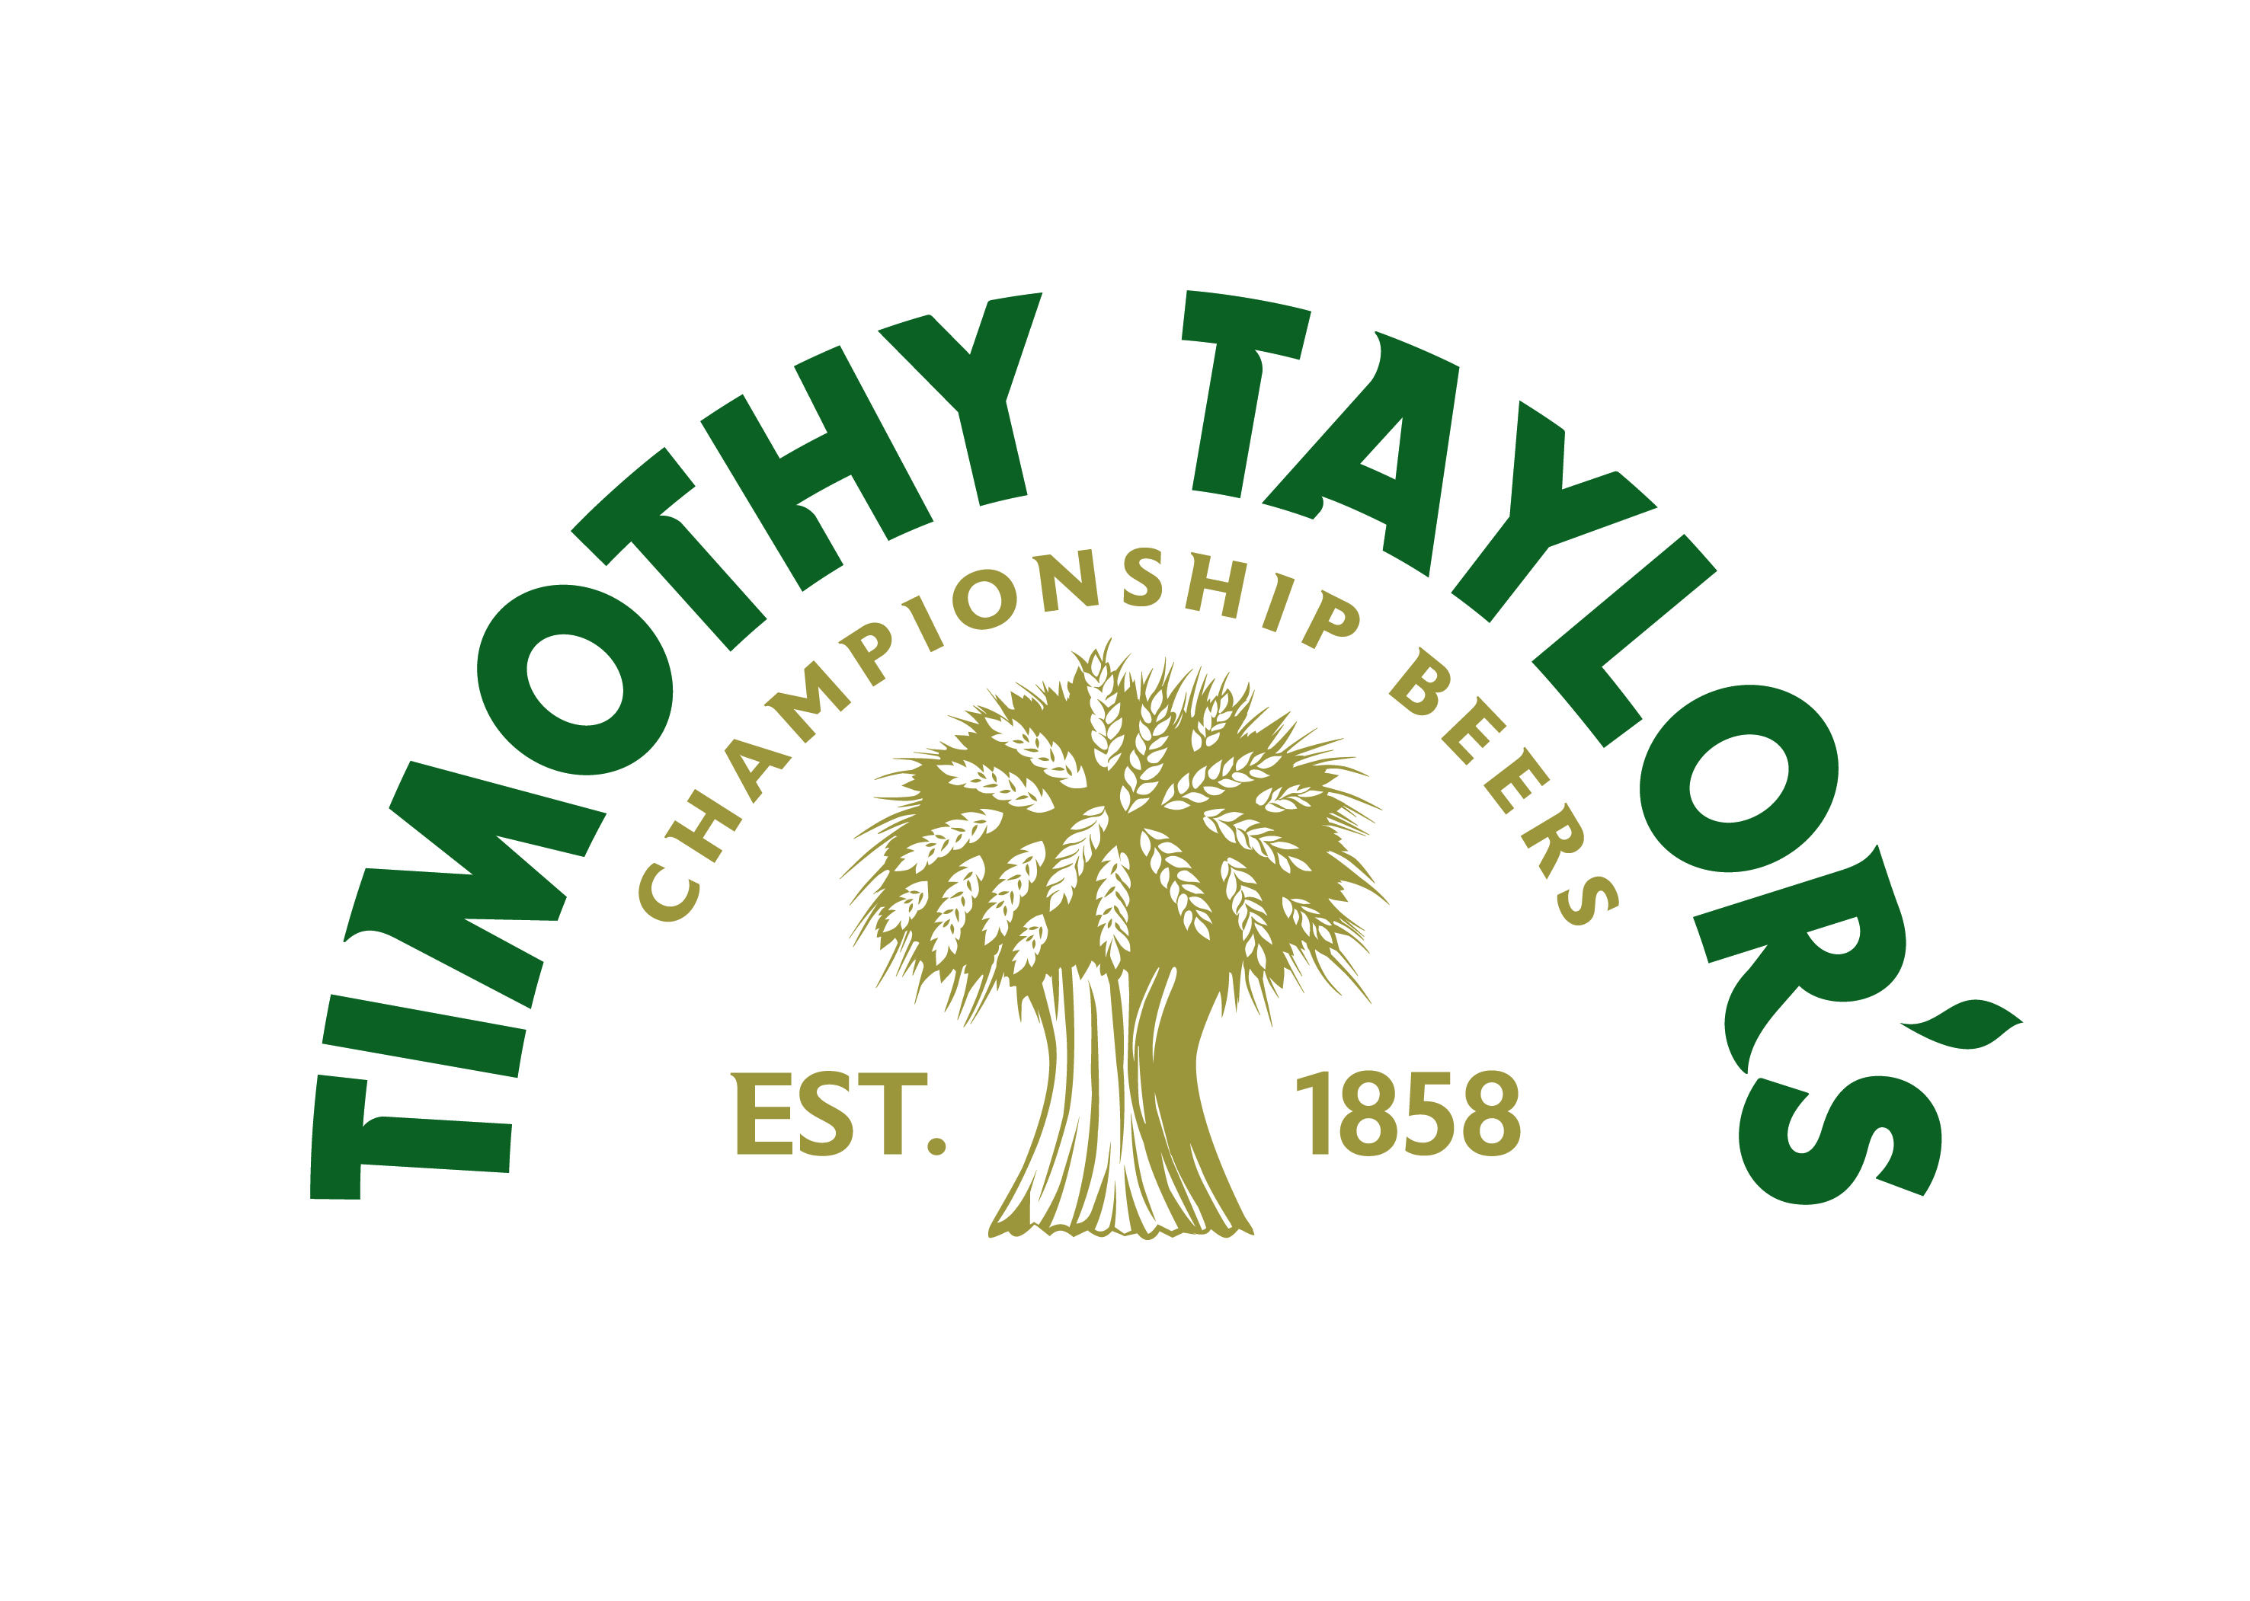
External Job Advert

Commercial Data Analyst
Location: Keighley, West Yorkshire

An exciting opportunity to join one of Britain’s most respected and award-winning, independent breweries, where insight, integrity and quality still take centre stage.

Why join Timothy Taylor’s?
At Timothy Taylor’s, we don’t just brew beer - we brew legacy. Still family-owned and proudly independent since 1858, we’ve built a reputation for doing things the right way, not the easy way. That goes for our people too.

We’re now looking for a detail-driven Commercial Data Analyst to join our Sales Department. If you take pride in making sense of complex information, enjoy spotting patterns and opportunities and want to play a vital role in shaping business decisions, this could be your next step.

The role: Commercial Data Analyst
As a Commercial Data Analyst, you’ll work closely with the Sales Director and colleagues across Sales, Marketing and Finance, providing insights that inform commercial strategy and customer engagement.

You’ll take ownership of reporting processes, ensure the accuracy of our CRM system and help the business make smarter, data-led decisions.

Key responsibilities:
- Leading improvements in tools, processes, and data collection methods.
- Ensuring CRM (SUGAR) data is accurate and reliable, providing training and documentation where needed.
- Liaising with our CRM provider to improve usability and reporting.
- Developing and maintaining monthly sales reports, dashboards and visualisations.
- Producing regular CRM-based reports for internal stakeholders.
- Monitoring and analysing promotional effectiveness to guide customer strategy.
- Presenting insights and recommendations clearly to senior stakeholders.
- Supporting Sales, Marketing and Finance with cross-functional projects and initiatives.
- Acting as a first point of contact for data-related queries and supporting the adoption of new technologies.

What makes this role rewarding?
- You’ll have real impact - Your analysis will directly shape sales strategy, promotions and customer engagement.
- You’ll be supported to grow - Whether deepening your technical toolkit or broadening your commercial knowledge, we’ll help you build confidence and expertise.

Who we are looking for
We would like someone who:

- Has experience in a Commercial Data Analyst role, or is a recent graduate in Data Science, Statistics, Mathematics, Computer Science, or similar, with strong analytical ability.
- Has experience in a FMCG or hospitality (not necessarily drinks industry experience).
- Is confident interpreting complex datasets, spotting trends and producing clear recommendations.
- Understands how data insight supports sales and business objectives.
- Communicates findings clearly to both technical and non-technical audiences.
- Maintains high standards for data accuracy and reporting quality.
- Works well with colleagues across functions, building strong and supportive relationships.
- Shows initiative, ownership and a drive to improve reporting and systems.

Desirable experience:
- Working with CRM systems, ideally SUGAR.
- Using Power BI and SQL.

Our culture
At Timothy Taylor’s, we believe in quality - not just in our products, but in our people and how we work. We are professional but down-to-earth, structured but friendly. We don’t believe in unnecessary bureaucracy, but we do believe in doing things properly - with integrity, precision and pride.

What we offer
We believe great work deserves great rewards. As part of the Timothy Taylor’s team, you’ll enjoy a comprehensive benefits package designed to support your wellbeing, work-life balance and long-term development:

- Salary dependent on experience, expected range £26,000 - £40,000.
- 25 days holiday, plus bank holidays.
- Workplace pension scheme.
- Annual bonus scheme.
- Private healthcare (with option to add family members).
- Annual occupational health assessments.
- Life insurance cover.
- Company sick pay scheme.
- Family-friendly pay policies.
- ‘WeCare’ – access to 24/7 GP consultations, mental health support, fitness programmes and more.
- Staff discount in our managed pubs.
- Cycle to Work scheme.
- Professional development support.
- Branded Timothy Taylor’s clothing.
- Free on-site parking.

Interested?
If you'd like to be considered for the role or know anyone who would be interested, please send your CV to jobs@timtaylors.co.uk, by no later than Friday 26 September 2025.

